Total Rewards
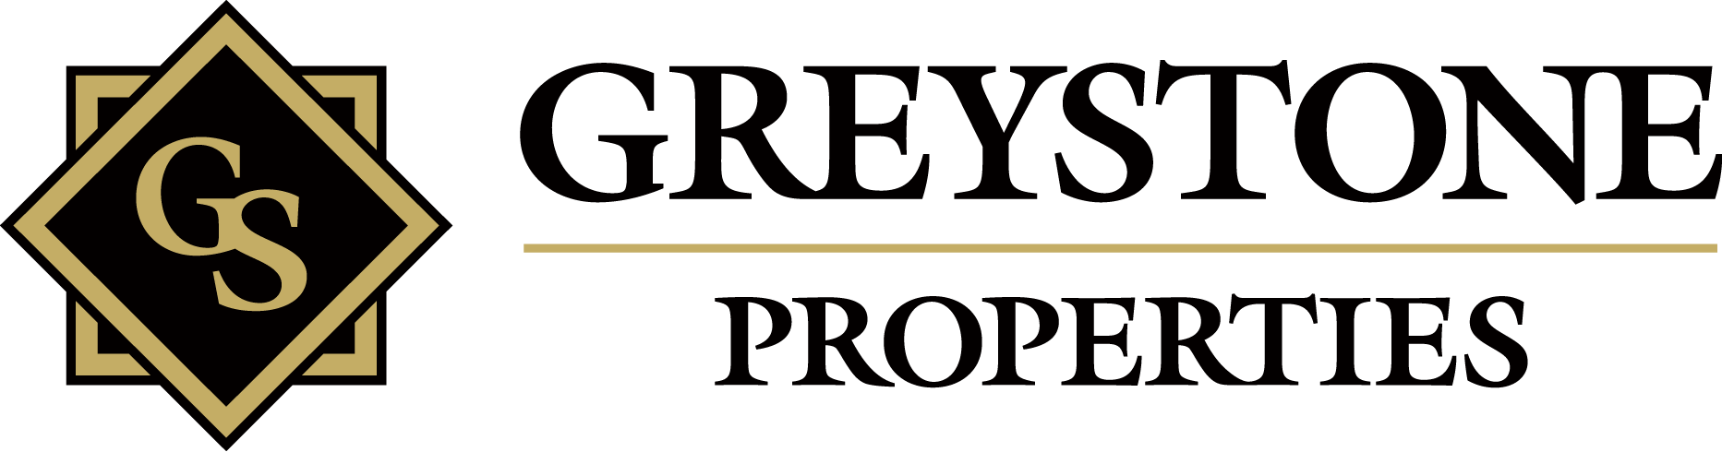
2015
Total Rewards
Employee Benefits & Services at Greystone
Presented by: Greystone Properties Human Resources

Working at Greystone is more than just a job; it is a rewarding career! As a part of the team, you will receive more than just health insurance benefits. Greystone offers a Total Rewards package which serves the many needs of our employees!

Benefits are determined by employee status and are subject to change. Speak to the Human Resources Department for details on any of the benefits listed in your Total Rewards Package.

